🧠 1. What is Clustering?
Answer:
Clustering is an unsupervised learning technique used to group similar data points together based on patterns or features without using labeled data.

🎯 2. Types of Clustering Algorithms

🔹 K-Means Clustering
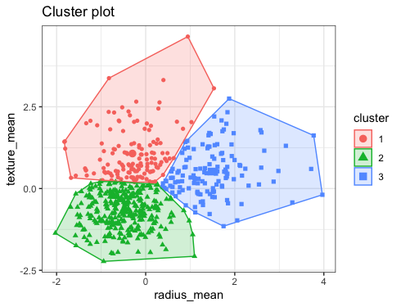
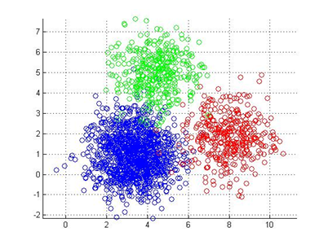
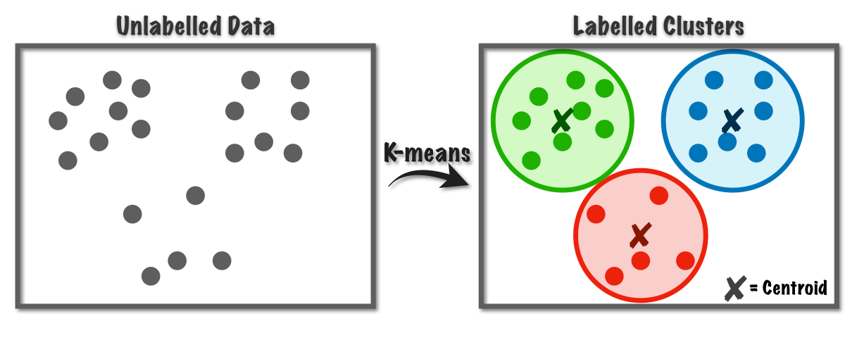
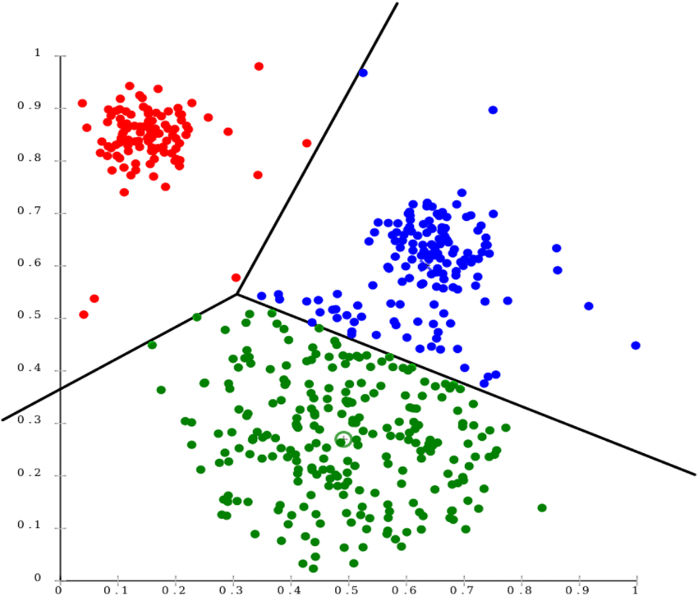
Answer:
K-Means divides data into K clusters by assigning points to the nearest centroid and updating centroids iteratively.

🔹 Hierarchical Clustering
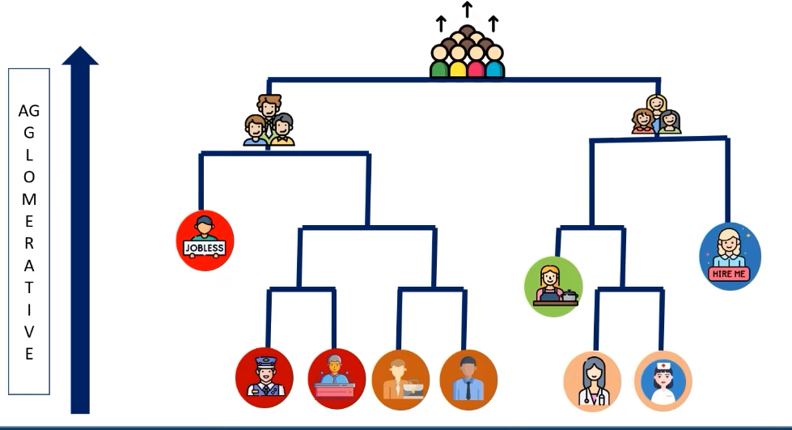
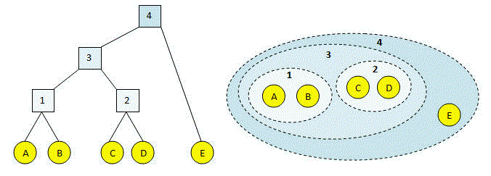
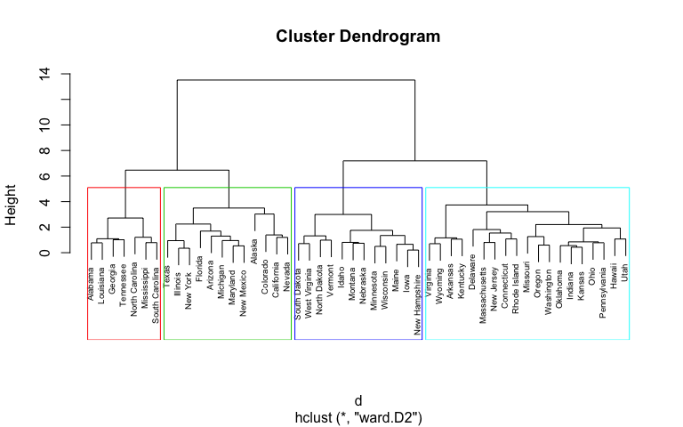
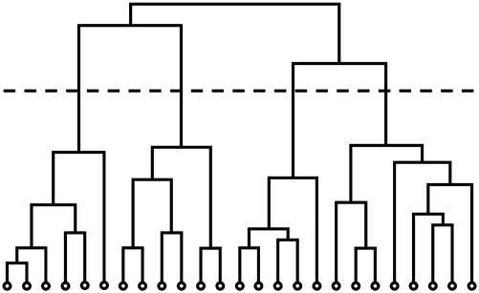
Answer:
It builds a tree-like structure (dendrogram) by merging or splitting clusters step by step.

🔹 DBSCAN
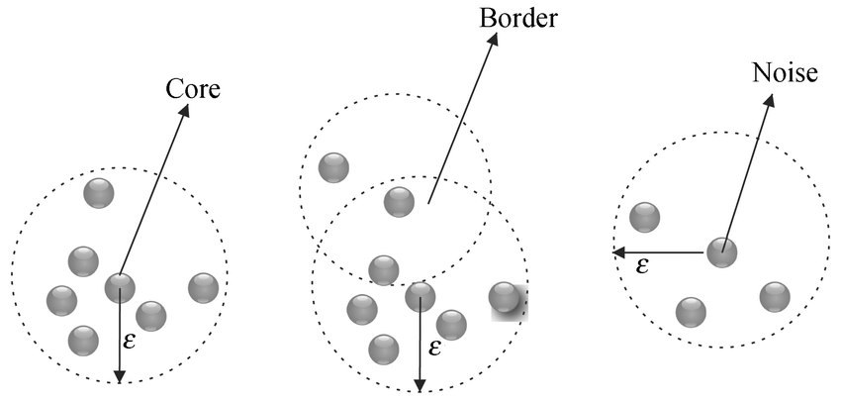
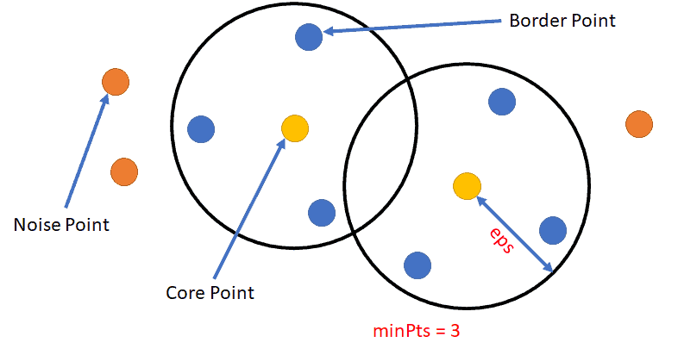
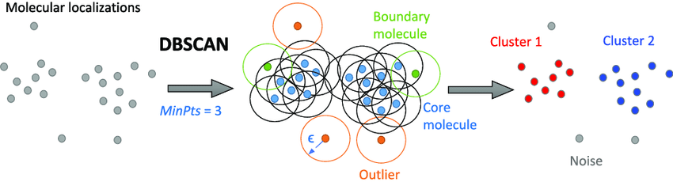
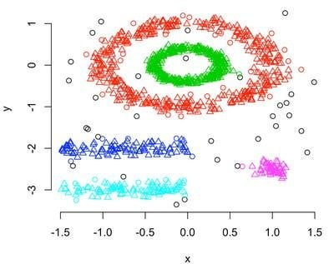
Answer:
DBSCAN groups points based on density and can detect noise/outliers effectively.

⚡ 3. Difference Between Clustering Algorithms
- K-Means: Fast but needs K value and struggles with outliers.
- Hierarchical: No need to choose K initially but slower.
- DBSCAN: Handles noise well and finds irregular shapes.

📊 4. How Do You Choose K in K-Means?
Answer:
Using the Elbow Method, where we plot error vs number of clusters and find the point where the curve bends.

📉 5. What is WCSS?
Answer:
Within Cluster Sum of Squares — measures how compact the clusters are.

🎯 6. What is Silhouette Score?
Answer:
It measures how well a data point fits within its cluster compared to other clusters.
👉 Range:
- Close to 1 → good clustering
- Close to 0 → overlapping clusters
- Negative → wrong clustering

🧠 7. Clustering vs Classification
Answer:
- Clustering → Unsupervised (no labels)
- Classification → Supervised (with labels)

🚀 8. What is Dimensionality Reduction?
Answer:
Reducing number of features while preserving important information.

🔹 PCA (Principal Component Analysis)
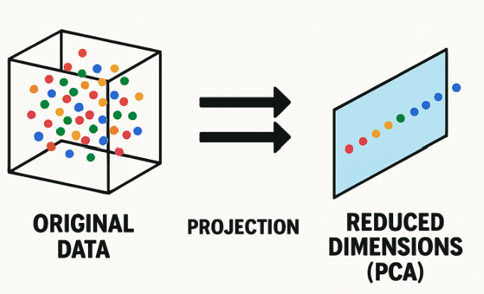
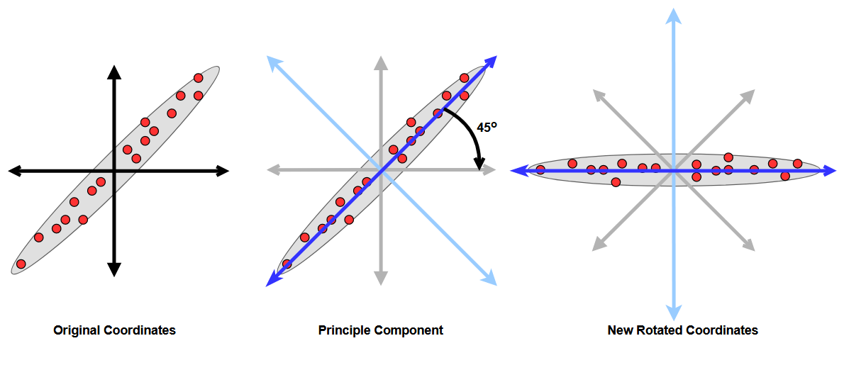
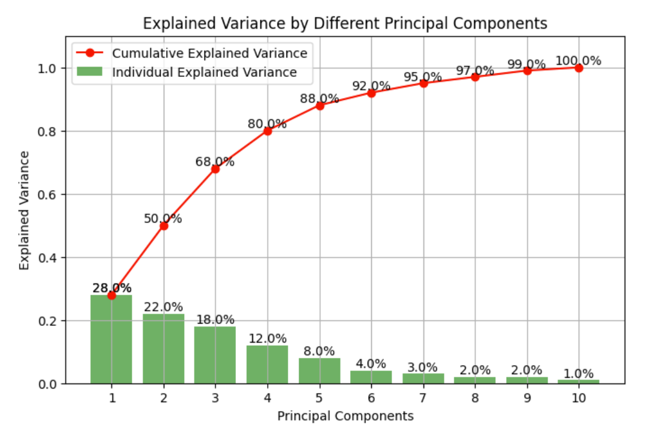

Answer:
PCA transforms data into new axes (principal components) that capture maximum variance.

⚙️ 9. Feature Engineering Questions

❓ What is Feature Engineering?
Answer:
Creating new features or modifying existing ones to improve model performance.

❓ Feature Selection vs Feature Extraction
Answer:
- Feature Selection → Choosing important features
- Feature Extraction → Creating new features (like PCA)

🔥 10. Advanced ML Questions (IMPORTANT)

❓ What is Cross-Validation?
Answer:
Splitting data multiple times to ensure model generalizes well.

❓ What is Hyperparameter Tuning?
Answer:
Adjusting model parameters (like number of trees in Random Forest) to improve performance.

❓ What is Gradient Descent?
Answer:
An optimization algorithm used to minimize error by updating weights iteratively.

📊 11. Real Interview Thinking Questions

❓ When will K-Means fail?
Answer:
- When clusters are not circular
- When data has noise/outliers
- When K is wrongly chosen

❓ When will you use DBSCAN instead of K-Means?
Answer:
- When data has noise
- When clusters are irregular

❓ Why PCA before clustering?
Answer:
To reduce dimensions and improve clustering performance.

🧩 12. Case-Based Questions (VERY IMPORTANT)

❓ How will you cluster customers?
Answer:
- Use features like age, income, spending
- Apply K-Means
- Analyze groups for marketing

❓ How will you detect fraud?
Answer:
- Use anomaly detection or clustering
- Identify unusual patterns

🏆 FINAL SMART LINE (USE THIS)
If stuck in interview:
“I would first understand the data, then choose the appropriate algorithm based on data distribution and problem type.”

🚀 Want next level prep?
I can:
- Give only high-probability questions for your college placements
- Take mock interview (with cross questioning)
- Help you answer based on your GitHub project
Just say: “next level questions” or “take my ML interview” 🔥

